Organization of important tools in the MEA-Tools suite
These charts are intended to illustrate the general layout of some important tools. For the sake of clarity, many functions internal to particular m-files were omitted, as were details of the internal flow within the m-files. A list of the calls to non-matlab files is given in the HTML-Documentation (call from MEA Tools/Documentation/M-file description/M-file reference (HTML) ).

Legend:
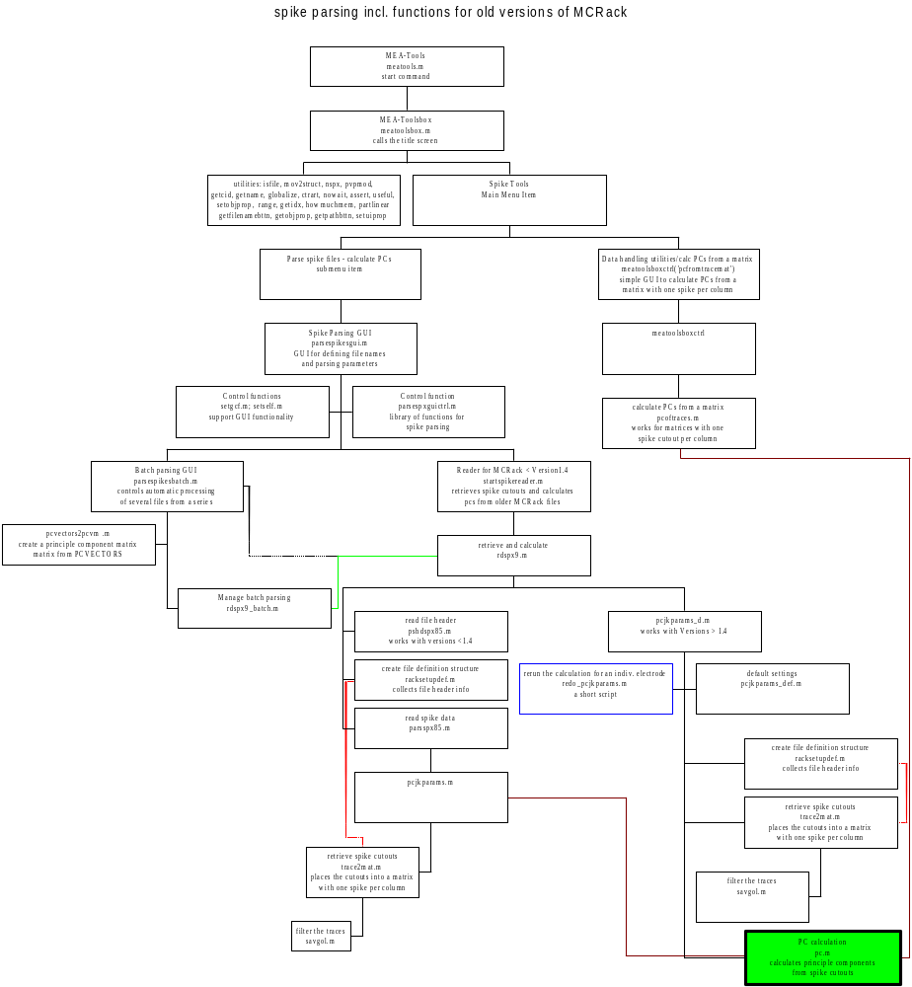red lines indicate upward flow
green lines indicate horizontal flow from left to right
pink lines indicate horizontal flow from right to left

blue box frames indicate functions or scripts that access another function without a GUI or that are not accessible through a GUI
red box frames indicate that this element accesses other important functions not shown in the diagram
green boxes show the target function for which the tree of tools and subfunctions was built.
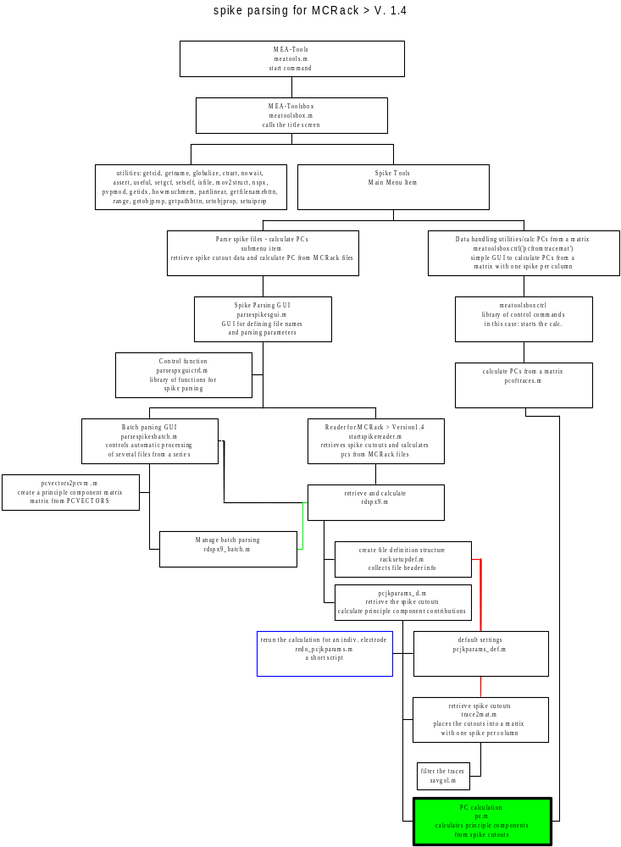
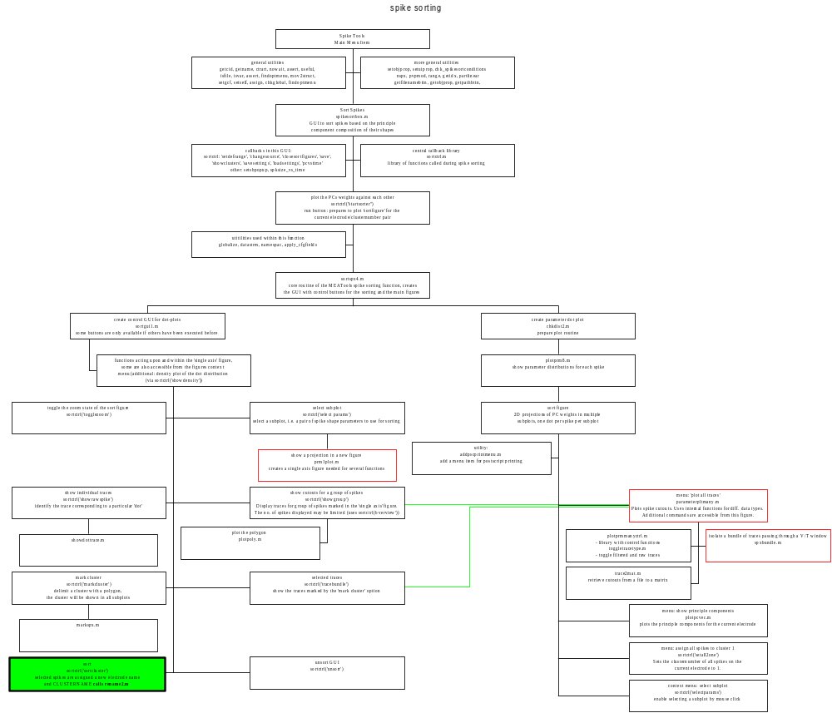

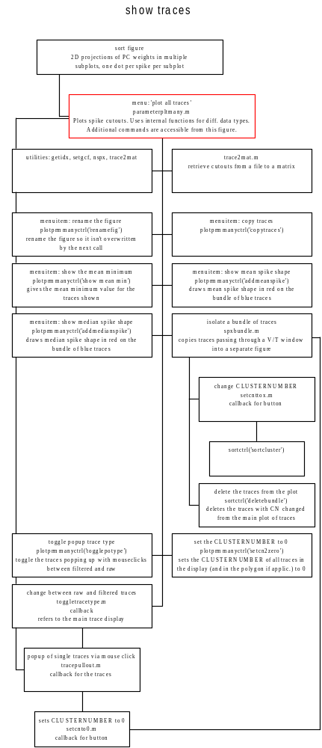Structure of the figure showing spike cutouts corresponding to dots in the 'single axis' figure as an overlay

